MICROSOFT OUTLOOK

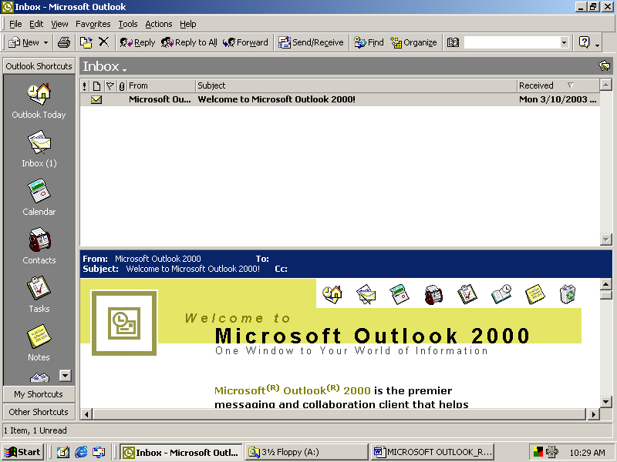

Training Reference Notes

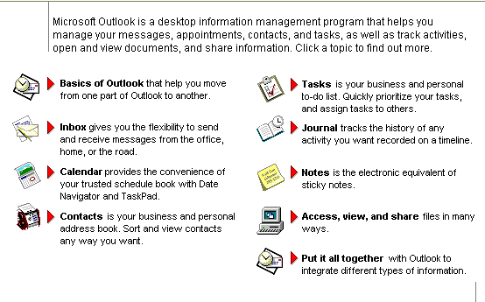

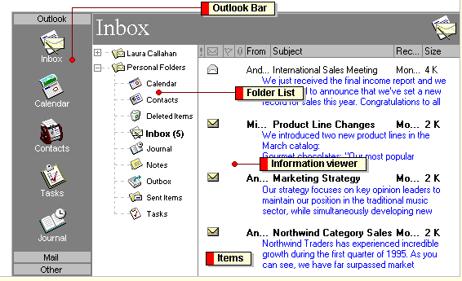

A: BASICS

OUTLOOK BAR
Click a Shortcut on the Outlook Bar to quickly open your favorite or most frequently used folders. You can add and remove Shortcuts, make them small or large, and hide the Outlook Bar. The Outlook Bar is divided into groups to help organize your information. Click a group, such as Mail, to move to a different set of Shortcuts. You can also create your own group and drag Shortcuts to different groups.

FOLDER LIST
To see all of your folders in Outlook at any time, click Folder List tool. The number in parentheses next to the folder names reflects the number of unread items in each folder. You can also display the Folder List by clicking the title of the open folder in the Folder Banner above the Folder List.

INFORMATION VIEW
Items in the selected folder are displayed in the information viewer. To change the way information displays, you can add and remove columns as well as sort, group, and filter items. you can also quickly select a different view in the Current View box .

ITEMS
Outlook is organized around types of items such as your mail messages, appointments, contacts, journal entries, tasks, and notes. To create an item, point to New on the File menu, and then click the type of item you want to create. To help you keep items organized, items are stored by type. For example, all mail messages are stored in the Inbox folder, and all tasks are stored in the Tasks folder. Folders that contain Outlook items are stored together in a single Outlook file so you can quickly find, categorize, and archive items.

B: INBOX
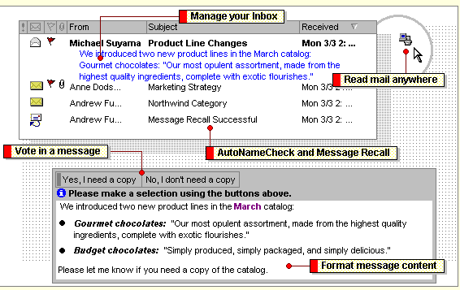

- With AutoPreview, you can preview the first few lines of text in all of your messages or only in the messages you haven't read.Use a Message Flag to indicate that a message requires a follow-up action or response, such as to resolve an issue by a certain date.If you use Microsoft Exchange Server, create rules to help you process and organize messages in your Inbox. For example, create a rule that moves all the messages from your manager into a separate folder or that forwards all the messages from a coworker to the rest of the team.

- You can use Outlook with a mail delivery service and a modem to send and receive messages from home, the office, the road, and even across the Internet. Work with mail messages from a remote location with the method that works best for you. With Remote Mail, you can quickly download message headers to preview the subject of messages and then decide if you want to download or delete each message. If you store information on Microsoft Exchange Server and use offline folders, you can synchronize all of your Outlook folders so your messages, appointments, tasks, and other information you work with offline matches the contents of the folders on the server.

- When you want others to answer a question, you can use voting buttons to collect the responses in e-mail. Outlook tallies the votes in the original message in your Sent Items folder, so you can quickly see all the responses in one place.

- Outlook checks the names you've selected before you send a message. If a name has more than one possible match, Outlook puts a wavy red or dashed green line under the name to remind you to verify the name before you send the message. You can recall a message after you send it as long as the recipient has not read it. For example, you may want to recall a message you sent to the wrong person or replace a message if you forgot to include an attachment.

- You can use a variety of fonts, font sizes, font styles, and colors in the text of a mail message. You can also change the way text is aligned and indented or use an automatic format to quickly create a bulleted list. Use AutoSignature to automatically add text to mail messages you send. For example, create an AutoSignature that includes your name, job title, and phone number. If you need additional formatting features such as tables or text highlighting, you can use Microsoft Word as your message editor.

Check for new messages

In most cases, messages are automatically received and appear in the Inbox. However, there are several ways to check for new messages based on how Outlook is set up. When you check for new messages, Outlook checks for messages sent to you and delivers messages you want sent to others. Try one of the following from your Inbox, based on your particular setup.

- On the Tools menu, click Check for New Mail. If you have multiple information services set up in your user profile, click Check for New Mail On (Tools menu), and then select the appropriate check boxes.

- If you use offline folders, point to Synchronize on the Tools menu, and then click This Folder.

Open a mail message

1 Click the Inbox folder.
2 In the message list, double-click the message you want.

Create a mail message

1 On the File menu, point to New, and then click Mail Message.
2 Enter recipient names in the To and Cc boxes.

To select recipient names from a list, click the To button or Cc button.

3 In the Subject box, type the subject of the message.
4 In the text box, type the message.
5 Click Send tool.

Send messages

In most cases, messages are automatically sent when you click Send tool. However, there are several ways to send messages, based on how Outlook is set up. When you check for new messages, Outlook checks for messages sent to you and delivers messages you want sent to others. Try one of the following from your Inbox, based on your particular setup.

- On the Tools menu, click Check for New Mail. If you have multiple information services set up in your user profile, click Check for New Mail On (Tools menu), and then select the appropriate check boxes.

Address a message

To quickly address a message, type the names of the recipients in the To, Cc, and Bcc boxes of a message. Separate names with a semicolon (;). If the box you want is not displayed, select the box name on the View menu. Outlook will try to match what you type with entries in the Address Book and will accept entries in standard Internet e-mail address format; for example, george@msn.com.

To quickly address a message to a contact, click Contacts tool, and then click the contact you want to send a message to. On the Contacts menu, click New Message to Contact. You can also address a message to someone on another e-mail system or to many recipients with a common interest by using a personal distribution list.

Preview the contents of messages

1 Click Inbox .
2 Click AutoPreview .

Note:
To preview the contents of unread messages only, on the View menu, click Format View, and then click Preview unread items.

Reply to a message

1 Open the message you want to reply to.

2 To reply to just the sender of the message, click Reply tool.

To reply to all recipients in the To and Cc boxes, click Reply to All tool.

Forward messages

- Click Inbox tool.
- Select the messages you want to forward.
- Click Forward tool.
- In the To and Cc boxes, enter recipient names.

To select recipient names from a list, click the To button or Cc button.

- If you are forwarding multiple messages, type the subject of the message in the Subject box.
- Click Send tool.

Note:
If you select multiple messages, they will be forwarded as attachments.

Re-send a message

You can only re-send messages you have sent.

1 On the Outlook Bar, click Mail.
2 Click Sent Items folder.
3 Open the message you want to resend.
4 On the Tools menu, click Resend This Message.

Move messages

- Click the Inbox folder.
- Select the messages you want to move.
- Click Move to Folder tool, and then click the name of the folder you want to move the messages to.

To move to a folder not listed, click Move to Folder, and then under Move the selected items to the folder, click the folder you want the messages moved to.

Copy messages

- Click the Inbox folder.
- Select the messages you want to copy.
- On the Edit menu, click Copy.
- If you want to place the copies in another folder, click the folder you want the messages copied to.
- On the Edit menu, click Paste.

Save an unfinished message

1 Click the message.
2 On the File menu, click Save.

Note:
The message is saved in the Inbox but is not sent.

Delete messages

1 Click the Inbox folder.
2 Select the messages you want to delete.
3 Click Delete tool.

C: Address Book

Use the Address Book dialog box to look up e-mail and fax information when you address messages. Use the Contacts folder to store and retrieve all types of information about others such as street addresses, telephone numbers, e-mail addresses, and fax phone numbers. Contacts in the Contacts folder that include an entry in the E-mail field or one of the fax phone number fields automatically appear in the Outlook Address Book in the Address Book dialog box. To open the Address Book dialog box, click Address Book tool, or click Address Book on the Tools menu.

There can be several types of address books in the Address Book dialog box including the Global Address List, Personal Address Book, and Outlook Address Book. Select these address books in the Show names from the box.

Part of Address Book | Description
Global Address List | The address book that contains all e-mail addresses for users, groups, and distribution lists in your organization that you can address messages to. The administrator creates and maintains this address book. The Global Address List may also contain public folder e-mail addresses.
Outlook Address Book | An address book automatically created from contacts in your Contacts folder that include an entry in the E-mail field or a fax phone number field. Your contacts can be people inside and outside your organization, and you can have multiple e-mail addresses for each contact. When you update your contacts in the Contacts folder, the Outlook Address Book updates as well.Your Contacts folder appears as a separate entry under Outlook Address Book in the Show names from the box (Address Book dialog box).
Personal Address Book | A customizable address book best used to store personal distribution lists you frequently address messages to, such as a list of everyone on the racquetball team. If you use Microsoft Exchange Server, you can also add an address for a public folder to the Personal Address Book. Personal Address Book files have a .pab extension and can be stored on a disk.

- You can add and remove the Outlook Address Book and Personal Address Book from your user profile.

- You can import Personal Address Books from Microsoft Mail 3.x or Microsoft Exchange Client into the Contacts folder or use them as they are in Outlook. However, any changes you make to a Personal Address Book in the Address Book dialog box are not updated in the Contacts folder.

Find names in the Address Book

- On the Tools menu, click the Address Book.
- In the Show names from the box, click the address book you want to search for names in.
- Click Find tool.
- Select the options you want.

D: CONTACTS

You can use this feature to keep contact details of people such as your business contacts and friends.

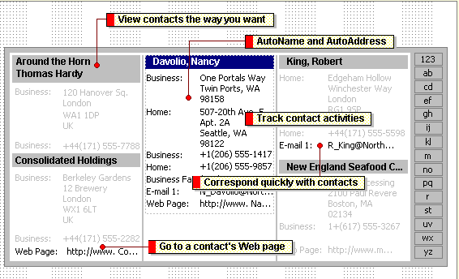

- You can file contact information under the last name, first name, company name, a nickname, or any word that helps you find the contact quickly; for example, "caterer." Outlook gives you several naming choices to file the contact under, or you can enter your own choice.

- You can view only the address and phone number you use most often or view all the addresses and phone numbers for a contact.

- When you enter a name or address for a contact, Outlook separates the name or address into parts and puts each part in a separate field. You can sort, group, or filter contacts by any part of the name or any part of the address you want.

- You can enter up to three addresses for any contact. Designate one address as the mailing address, and use it for mailing labels and Mail Merge in Word.

- You can quickly view recorded activities for each contact in your contact list. For example, you may want to quickly review all the conversations or meetings you had with a particular contact. Just open the contact, and click the Journal tab. Journal entries you view from Contacts are the same journal entries you see in Journal.

- From a contact in your contact list, you can click a button or menu command to have Outlook address a meeting request, mail message, or task request to the contact. If you have a modem, you can also have Outlook dial the contact's phone number. You can have Outlook time the call and keep a record in Journal complete with notes you take during the conversation.

E: SET UP WHERE AND HOW E-MAIL IS DELIVERED

Based on your situation, there are different ways to configure Outlook to send and receive e-mail messages. You can set the location you send and receive messages from as well as the method you use.

If you work for an organization, check with your administrator to see what solution is best for you. Otherwise, you can use one of the following most common scenarios as a guide.

Scenario | Location you send and receive messages from | Method you use to send and receive messages
If you work in an organization and use Microsoft Exchange Server | Microsoft Exchange Server mailbox | Automatic.
If you work in an organization and use Microsoft Exchange Server, and you have a laptop computer or a docking computer you use on the road | Offline folder file (OST) | Offline folders. Automatic when connected. Use the Synchronize command (Tools menu) when not connected.
If you use only a mail delivery service such as MSN, The Microsoft Network or AOL | Personal folder file (PST) | Remote Mail. Use the Remote Mail command (Tools menu).

